|  |  | LISTENING  UNIT 9 |  |
| --- | --- | --- | --- |

# **DESCRIPTION OF A COMPANY**

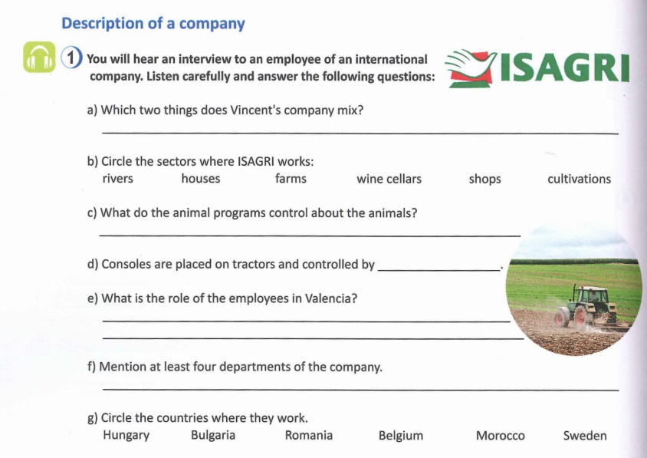

EXERCISE 1

| a) |
| --- |
| b) |
| c) |
| d) |
| e) |
| f) |
| g) |

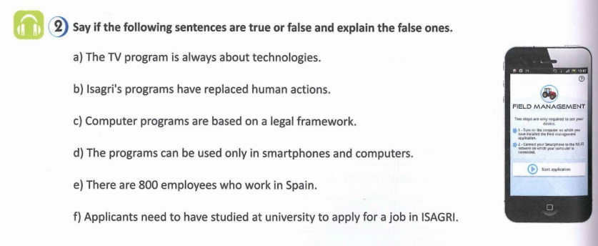

EXERCISE 2

| a) |
| --- |
| b) |
| c) |
| d) |
| e) |
| f) |